Stepper Motor 5V 4-Phase 5-Wire & ULN2003 Driver Board for Arduino
From Geeetech Wiki
Jump to: navigation, search

Contents
[hide]
- 1 Stepper Introduction
- 2 Features
- 3 Stepper motor 28BYJ-48 Parameters
- 4 Interfacing circuits
- 5 Example code
  - 5.1 Code
  - 5.2 Stepper library
- 6 Document
- 7 Reference Materials
- 8 How to buy

Stepper Introduction
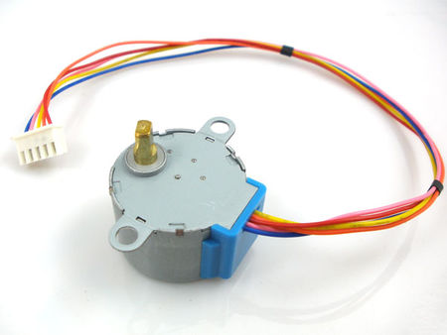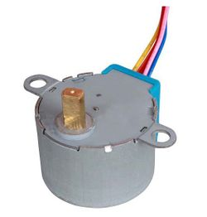
A stepper motor is an electromechanical device which converts electrical pulses into discrete mechanical movements. The shaft or spindle of a stepper motor rotates in discrete step increments when electrical command pulses are applied to it in the proper sequence. The motors rotation has several direct relationships to these applied input pulses. The sequence of the applied pulses is directly related to the direction of motor shafts rotation. The speed of the motor shafts rotation is directly related to the frequency of the input pulses and the length of rotation is directly related to the number of input pulses applied.One of the most significant advantages of a stepper motor is its ability to be accurately controlled in an open loop system. Open loop control means no feedback information about position is needed. This type of control eliminates the need for expensive sensing and feedback devices such as optical encoders. Your position is known simply by keeping track of the input step pulses.

Features
- The rotation angle of the motor is proportional to the input pulse.
- The motor has full torque at standstill(if the windings are energized)
- Precise positioning and repeatability of movement since good stepper motors have an accuracy of – 5% of a step and this error is non cumulative from one step to the next.
- Excellent response to starting/stopping/reversing.
- Very reliable since there are no contact brushes in the motor. Therefore the life of the motor is simply dependant on the life of the bearing.
- The motors response to digital input pulses provides open-loop control, making the motor simpler and less costly to control.
- It is possible to achieve very low speed synchronous rotation with a load that is directly coupled to the shaft.
- A wide range of rotational speeds can be realized as the speed is proportional to the frequency of the input pulses.

Stepper motor 28BYJ-48 Parameters
- Model ： 28BYJ-48
- Rated voltage ： 5VDC
- Number of Phase ： 4
- Speed Variation Ratio ： 1/64
- Stride Angle ： 5.625° /64
- Frequency : 100Hz
- DC resistance ： 50Ω±7%(25℃)
- Idle In-traction Frequency : > 600Hz
- Idle Out-traction Frequency : > 1000Hz
- In-traction Torque >34.3mN.m(120Hz)
- Self-positioning Torque >34.3mN.m
- Friction torque : 600-1200 gf.cm
- Pull in torque : 300 gf.cm
- Insulated resistance >10MΩ(500V)
- Insulated electricity power ：600VAC/1mA/1s
- Insulation grade ：A
- Rise in Temperature <40K(120Hz)
- Noise <35dB(120Hz,No load,10cm)

Interfacing circuits
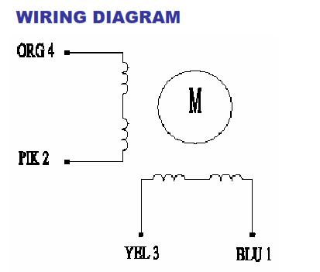
The bipolar stepper motor usually has four wires coming out of it. Unlike unipolar steppers, bipolar steppers have no common center connection. They have two independent sets of coils instead. You can distinguish them from unipolar steppers by measuring the resistance between the wires. You should find two pairs of wires with equal resistance. If you’ve got the leads of your meter connected to two wires that are not connected (i.e. not attached to the same coil), you should see infinite resistance (or no continuity).
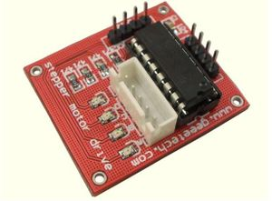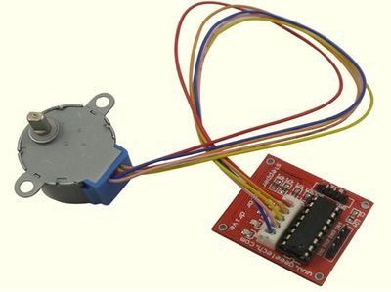
The simplest way of interfacing a unipolar stepper to Arduino is to use a breakout for ULN2003A transistor array chip. The ULN2003A contains seven darlington transistor drivers and is somewhat like having seven TIP120 transistors all in one package. The ULN2003A can pass up to 500 mA per channel and has an internal voltage drop of about 1V when on. It also contains internal clamp diodes to dissipate voltage spikes when driving inductive loads.To control the stepper, apply voltage to each of the coils in a specific sequence.
The sequence would go like this:
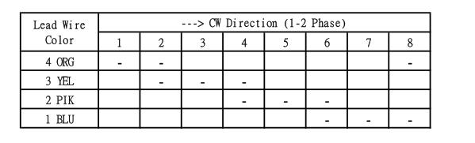
Here are schematics showing how to interface a unipolar stepper motor to four controller pins using a ULN2003A, and showing how to interface using four TIP120's.
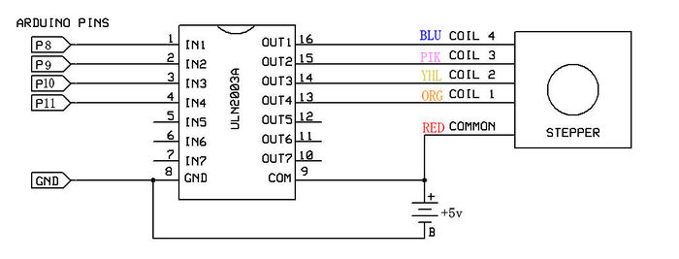

Example code

Code
int Pin0 = 10;
int Pin1 = 11;
int Pin2 = 12;
int Pin3 = 13;
int _step = 0;
boolean dir = true;// gre
void setup()
{
pinMode(Pin0, OUTPUT);
pinMode(Pin1, OUTPUT);
pinMode(Pin2, OUTPUT);
pinMode(Pin3, OUTPUT);
}
void loop()
{
switch(_step){
case 0:
digitalWrite(Pin0, LOW);
digitalWrite(Pin1, LOW);
digitalWrite(Pin2, LOW);
digitalWrite(Pin3, HIGH);
break;
case 1:
digitalWrite(Pin0, LOW);
digitalWrite(Pin1, LOW);
digitalWrite(Pin2, HIGH);
digitalWrite(Pin3, HIGH);
break;
case 2:
digitalWrite(Pin0, LOW);
digitalWrite(Pin1, LOW);
digitalWrite(Pin2, HIGH);
digitalWrite(Pin3, LOW);
break;
case 3:
digitalWrite(Pin0, LOW);
digitalWrite(Pin1, HIGH);
digitalWrite(Pin2, HIGH);
digitalWrite(Pin3, LOW);
break;
case 4:
digitalWrite(Pin0, LOW);
digitalWrite(Pin1, HIGH);
digitalWrite(Pin2, LOW);
digitalWrite(Pin3, LOW);
break;
case 5:
digitalWrite(Pin0, HIGH);
digitalWrite(Pin1, HIGH);
digitalWrite(Pin2, LOW);
digitalWrite(Pin3, LOW);
break;
case 6:
digitalWrite(Pin0, HIGH);
digitalWrite(Pin1, LOW);
digitalWrite(Pin2, LOW);
digitalWrite(Pin3, LOW);
break;
case 7:
digitalWrite(Pin0, HIGH);
digitalWrite(Pin1, LOW);
digitalWrite(Pin2, LOW);
digitalWrite(Pin3, HIGH);
break;
default:
digitalWrite(Pin0, LOW);
digitalWrite(Pin1, LOW);
digitalWrite(Pin2, LOW);
digitalWrite(Pin3, LOW);
break;
}
if(dir){
_step++;
}else{
_step--;
}
if(_step>7){
_step=0;
}
if(_step<0){
_step=7;
}
delay(1);
}

Stepper library
The Arduino programming environment comes with a function library for controlling a stepper motor. To use the library, in the Arduino Editor from the top menu bar: Sketch > Import Library > Stepper. Copy the example code below into an Arduino program.
Arduino Example Code Notes :
- The example code assumes that the stepper is being controlled by Arduino pins 8, 9, 10 and 11, but you can use any set of four pins.
- The "#define STEPS 100" line defines the number of steps per rev. A 3.75 deg motor has 96 steps/rev while a 7.2 deg motor has 48 steps/rev.
- The "Stepper stepper(STEPS, 8, 9, 10, 11)" line is where you enter the four pins used to control the stepper.
- The "stepper.setSpeed(x)" command sets the motor speed to x rpm.
- The "stepper.step(x)" command turns the motor x steps at the speed last set in the stepper.setSpeed() command. The motor turns one direction for postive x and the reverse direction for negative x.

Document
- Stepper motor basic
- Stepper Motor Datasheet
- ULN2003 Datasheet

Reference Materials
- tigoe's blog http://www.tigoe.net/pcomp/code/circuits/motors/stepper-motors/
- silveir' blog http://silveiraneto.net/?s=stepper
- ME arduino course http://www.me.umn.edu/courses/me2011/arduino/technotes/stepper/index.html

How to buy
Click here to buy 5V 4-Phase 5-Wire Stepper Motor and Stepper Motor Driver Board ULN2003 for Arduino
Retrieved from "http://www.geeetech.com/wiki/index.php?title=Stepper_Motor_5V_4-Phase_5-Wire_%26_ULN2003_Driver_Board_for_Arduino&oldid=1999"

Personal tools
- Log in

Namespaces
- Page
- Discussion

Variants

Views
- Read
- View source
- View history

Actions

Search
表單的頂端

表單的底部

Navigation
- Main page
- product
- Experiment
- Tutorials

Friendly ARM
- Mini2440
- Micro2440
- Mini6410
- Tiny6410
- Mini210
- Mini210s
- Tiny210

Links
- Forum
- Bazzar
- Blog
- Contact us

Toolbox
- What links here
- Related changes
- Special pages
- Printable version
- Permanent link
- This page was last modified on 28 July 2012, at 02:31.
- This page has been accessed 18,603 times.
- Privacy policy
- About Geeetech Wiki
- Disclaimers

Stepper Motors
A stepper motor is a motor controlled by a series of electromagnetic coils. The center shaft has a series of magnets mounted on it, and the coils surrounding the shaft are alternately given current or not, creating magnetic fields which repulse or attract the magnets on the shaft, causing the motor to rotate.
This design allows for very precise control of the motor: by proper pulsing, it can be turned in very accurate steps of set degree increments (for example, two-degree increments, half-degree increments, etc.). They are used in printers, disk drives, and other devices where precise positioning of the motor is necessary.
There are two basic types of stepper motors, unipolar steppers and bipolar steppers.
Unipolar Stepper Motors
The unipolar stepper motor has five or six wires and four coils (actually two coils divided by center connections on each coil). The center connections of the coils are tied together and used as the power connection. They are called unipolar steppers because power always comes in on this one pole.
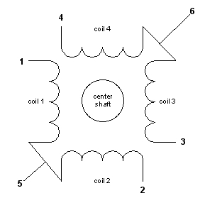
Bipolar stepper motors
The bipolar stepper motor usually has four wires coming out of it. Unlike unipolar steppers, bipolar steppers have no common center connection. They have two independent sets of coils instead. You can distinguish them from unipolar steppers by measuring the resistance between the wires. You should find two pairs of wires with equal resistance. If you’ve got the leads of your meter connected to two wires that are not connected (i.e. not attached to the same coil), you should see infinite resistance (or no continuity).
Like other motors, stepper motors require more power than a microcontroller can give them, so you’ll need a separate power supply for it. Ideally you’ll know the voltage from the manufacturer, but if not, get a variable DC power supply, apply the minimum voltage (hopefully 3V or so), apply voltage across two wires of a coil (e.g. 1 to 2 or 3 to 4) and slowly raise the voltage until the motor is difficult to turn. It is possible to damage a motor this way, so don’t go too far. Typical voltages for a stepper might be 5V, 9V, 12V, 24V. Higher than 24V is less common for small steppers, and frankly, above that level it’s best not to guess.
To control the stepper, apply voltage to each of the coils in a specific sequence. The sequence would go like this:
Step | wire 1 | wire 2 | wire 3 | wire 4
1 | High | low | high | low
2 | low | high | high | low
3 | low | high | low | high
4 | high | low | low | high
To control a unipolar stepper, you use a Darlington Transistor Array. The stepping sequence is as shown above. Wires 5 and 6 are wired to the supply voltage.
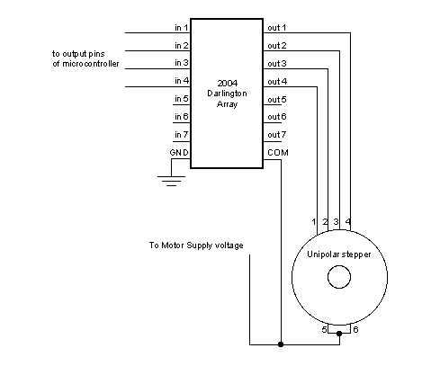
To control a bipolar stepper motor, you give the coils current using to the same steps as for a unipolar stepper motor. However, instead of using four coils, you use the both poles of the two coils, and reverse the polarity of the current.
The easiest way to reverse the polarity in the coils is to use a pair of H-bridges. The L293D dual H-bridge has two H-bridges in the chip, so it will work nicely for this purpose.
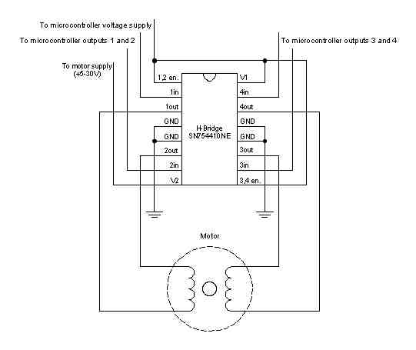
Once you have the motor stepping in one direction, stepping in the other direction is simply a matter of doing the steps in reverse order.
Knowing the position is a matter of knowing how many degrees per step, and counting the steps and multiplying by that many degrees. So for examples, if you have a 1.8-degree stepper, and it’s turned 200 steps, then it’s turned 1.8 x 200 degrees, or 360 degrees, or one full revolution.
Two-Wire Control
Thanks to Sebastian Gassner for ideas on how to do this.
In every step of the sequence, two wires are always set to opposite polarities. Because of this, it’s possible to control steppers with only two wires instead of four, with a slightly more complex circuit. The stepping sequence is the same as it is for the two middle wires of the sequence above:
Step | wire 1 | wire 2
1 | low | high
2 | high | high
3 | high | low
4 | low | low
The circuits for two-wire stepping are as follows:
Unipolar stepper two-wire circuit:
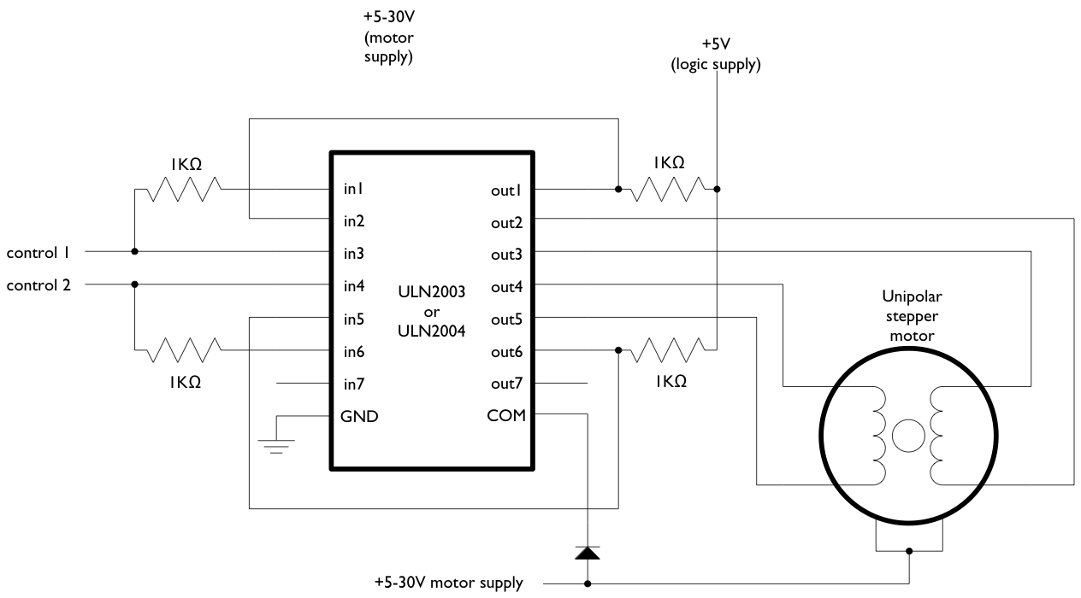
Biolar stepper two-wire circuit:
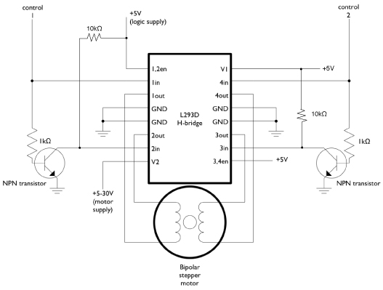
Programming the Microcontroller to Control a Stepper
Because both unipolar and bipolar stepper motors are controlled by the same stepping sequence, we can use the same microcontroller code to control either one. In the code examples below, connect either the Darlington transistor array (for unipolar steppers) or the dual H-bridge (for bipolar steppers) to the pins of your microcontroller as described in each example. There is a switch attached to the microcontroller as well. When the switch is high, the motor turns one direction. When it’s low, it turns the other direction.
The examples below use the 4-wire stepping sequence. A two-wire control program is shown for the Wiring/Arduino Stepper library only.
Wire pins 9-12 of the BX-24 to inputs 1-4 of the Darlington transistor array, respectively. If you’re using the PicBasic Pro code, it’s designed for a PIC 40-pin PIC such as the 16F877 or 18F452. Use pins PORTD.0 through PORTD.3, respectively. If you’re using a smaller PIC, you can swap ports, as long as you use the first four pins of the port.
Note that the wires read from left to right. Their numbers don’t correspond with the bit positions. For example, PORTD.3 would be wire 1, PORTD.2 would be wire 2, PORTD.1 would be wire 3, and PORTD.0 would be wire 4. On the BX-24, pin 9 is wire 1, pin 10 is wire 2, and so forth.
BX-24 code:
dim motorStep(1 to 4) as byte
dim thisStep as integer

Sub main()
call delay(0.5) ' start program with a half-second delay

dim i as integer

' save values for the 4 possible states of the stepper motor leads
' in a 4-byte array. the stepMotor routine will step through
' these four states to move the motor. This is a way to set the
' value on four pins at once. The eight pins 5 through 12 are
' represented in memory as a byte called register.portc. We will set
' register.portc to each of the values of the array in order to set
' pins 9,10,11, and 12 at once with each step.

motorStep(0) = bx0000_1010
motorStep(1) = bx0000_0110
motorStep(2) = bx0000_0101
motorStep(3) = bx0000_1001

' set the last 4 pins of port C to output:
register.ddrc = bx0000_1111

' set all the pins of port C low:
register.portc = bx0000_0000

do
' move motor forward 100 steps.
' note: by doing a modulo operation on i (i mod 4),
' we can let i go as high as we want, and thisStep
' will equal 0,1,2,3,0,1,2,3, etc. until the end
' of the for-next loop.

for i = 1 to 100
thisStep = i mod 4
call stepMotor(thisStep)
next

' move motor backward
for i = 100 to 1 step -1
thisStep = i mod 4
call stepMotor(thisStep)
next
loop

End Sub

sub stepMotor(byref whatStep as integer)
' sets the value of the eight pins of port c to whatStep
register.portc = motorStep(whatStep)

call delay (0.1) ' vary this delay as needed to make your stepper step.
end sub

PicBasic Pro code:
start:
High PORTB.0

' set variables:
x VAR BYTE
steps VAR WORD
stepArray VAR BYTE(4)
clear

TRISD = %11110000
PORTD = 255
input portb.4
Pause 1000

stepArray[0] = %00001010
stepArray[1] = %00000110
stepArray[2] =%00000101
stepArray[3] = %00001001

main:
if portb.4 = 1 then
steps = steps + 1
else
steps = steps - 1
endif

portD = stepArray[steps //4]
pause 2

GoTo main

pBasic (Basic Stamp 2) code:

' set variables:
x var byte
stepper var nib
steps var word

' set pins 8 - 10 as outputs, using DIRS to do so:
dirs.highbyte = %00001111

main:
steps = 200
gosub clockStep
pause 1000
gosub counterClockStep
pause 1000
goto main

clockStep:
debug "counter" , cr
for x = 0 to steps
lookup x//4, [%1010,%1001,%0101,%0110], stepper
outs.highbyte.lownib = stepper
pause 2
next
return

counterclockStep:
debug "clockwise", cr
for x = 0 to steps
lookup x//4, [%0110,%0101,%1001,%1010], stepper
outs.highbyte.lownib = stepper
pause 2
next
return

Wiring Code (for Arduino board):
This example uses the Stepper library for Wiring/Arduino. It was tested using the 2-wire circuit. To change to the 4-wire circuit, just add two more motor pins, and change the line that initalizes the Stepper library like so:
Stepper myStepper(motorSteps, motorPin1,motorPin2,motorPin3,motorPin4);
/*
Stepper Motor Controller
language: Wiring/Arduino

This program drives a unipolar or bipolar stepper motor.
The motor is attached to digital pins 8 and 9 of the Arduino.

The motor moves 100 steps in one direction, then 100 in the other.

Created 11 Mar. 2007
Modified 7 Apr. 2007
by Tom Igoe

*/

// define the pins that the motor is attached to. You can use
// any digital I/O pins.

#include <Stepper.h>

#define motorSteps 200 // change this depending on the number of steps
// per revolution of your motor
#define motorPin1 8
#define motorPin2 9
#define ledPin 13

// initialize of the Stepper library:
Stepper myStepper(motorSteps, motorPin1,motorPin2);

void setup() {
// set the motor speed at 60 RPMS:
myStepper.setSpeed(60);

// Initialize the Serial port:
Serial.begin(9600);

// set up the LED pin:
pinMode(ledPin, OUTPUT);
// blink the LED:
blink(3);
}

void loop() {
// Step forward 100 steps:
Serial.println("Forward");
myStepper.step(100);
delay(500);

// Step backward 100 steps:
Serial.println("Backward");
myStepper.step(-100);
delay(500);

}

// Blink the reset LED:
void blink(int howManyTimes) {
int i;
for (i=0; i< howManyTimes; i++) {
digitalWrite(ledPin, HIGH);
delay(200);
digitalWrite(ledPin, LOW);
delay(200);
}
}
For more on steppers, see the DC motor notes on this site.

For more on steppers, see the DC motor notes on this site.

8 Responses to Stepper Motors
- Pingback: Circuitos « Projeto 58
- Pingback: Ruler Clock - Hacked Gadgets - DIY Tech Blog
- Pingback: Make It Last Build Series #3: Prototyping the Stepper Driver | dev.SquareCows.com
- Pingback: Dual H Bridge: L293D | Christoph Hartel
- Pingback: Wireless control of a pan & tilt head with Arduino, L293D motor controller and TV IR remote control | Christoph Hartel
- Pingback: Skaner 3D oparty na Arduino i Processing » Majsterkowo.pl
- Pingback: Plog of James Dolan » Archives » Unipolar Stepper Motor – Arduino Controlled
- Pingback: Plog of James Dolan » Archives » Bipolar Stepper Motor – Arduino Controlled

5V 4-Phase 5-Wire Stepper Motor
- 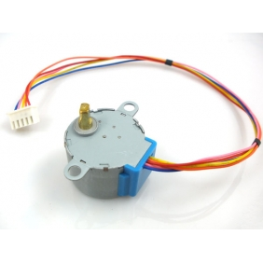
click on image to enlarge

  - 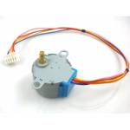

  - 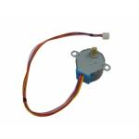

Tell a friend about this product
Share on facebookShare on twitterShare on emailShare on printMore Sharing Services0

Pricing Model: BOT-06640
Shipping Weight: 50g

表單的頂端
 | 574 Units in Stock
price | $5.50
10-49 | $5.34
50-99 | $5.23
100+ | $5.06
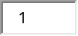 | quantity
表單的底部

Product Info
表單的頂端
Description:
5 Line 4 phase can be driven by ordinary ULN2003 chip can also be connected in phase 2 development board used for supporting the use of a direct plug and easy to use stepper motor used in the development board.
Specification:
Diameter: 28mm
Voltage: 5V
Step angle: 5.625 x 1 / 64
Reduction ratio: 1 / 64
For more information of this product, please visit theWiki PAGE
Downloads:
5V Stepper Motor Document.pdf
Stepper motor basic.pdf
Stepper motor datasheet.pdf

表單的底部

